**DEPARTMENT OF INFORMATION TECHNOLOGY, NITK SURATHKAL**

**Parallel Computing**

**LAB 1**

**Name:** Chinmayi C. Ramakrishna

**Roll No:** 181IT113

**CPU Details:**

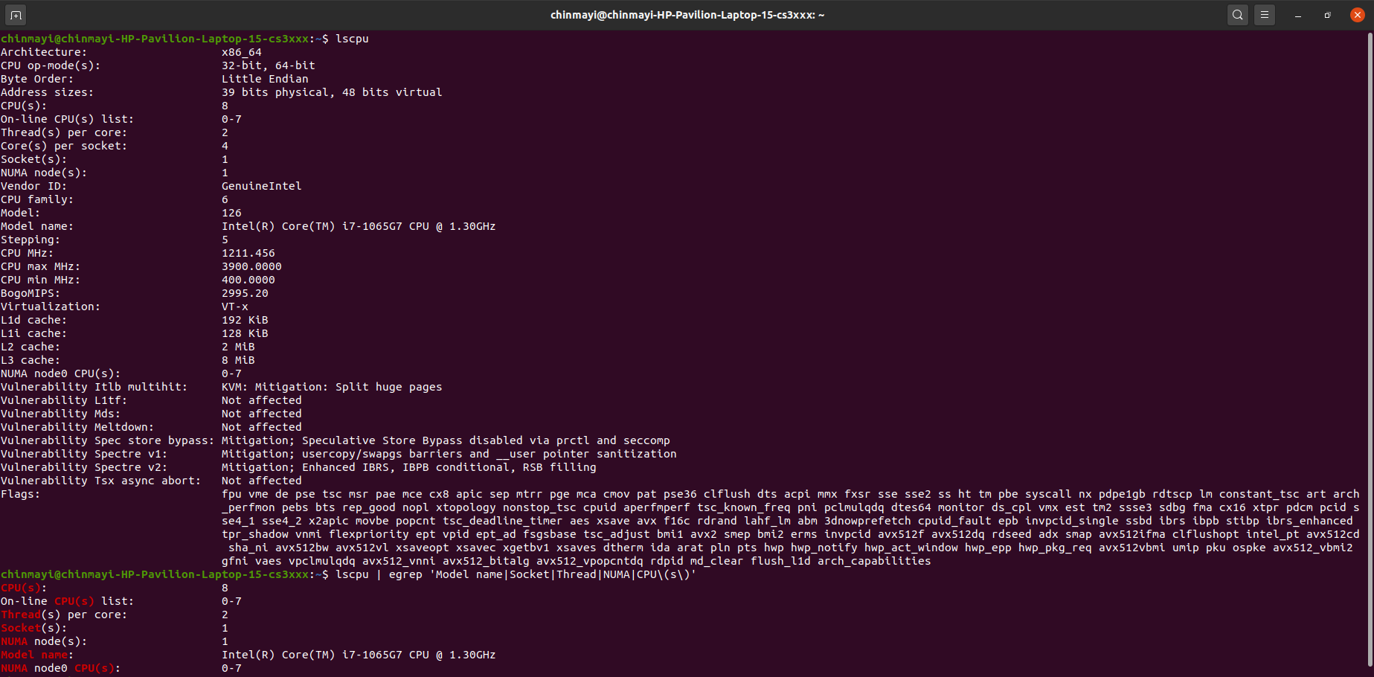

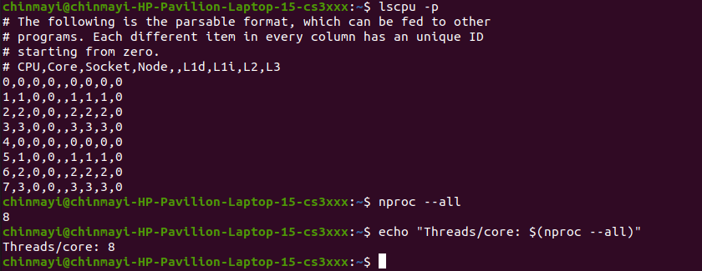

**1.Write a C/C++ simple parallel program to display the *thread_id* and**

**total number of threads.**

1. **Using OMP_NUM_THREADS**

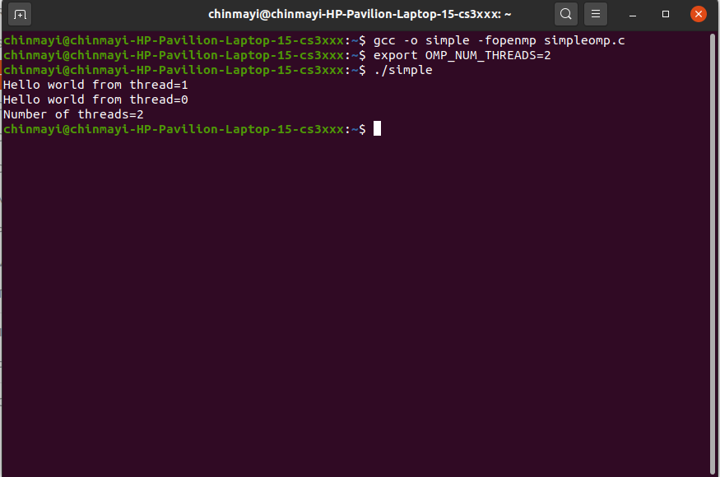

1. **Using num_threads() method**

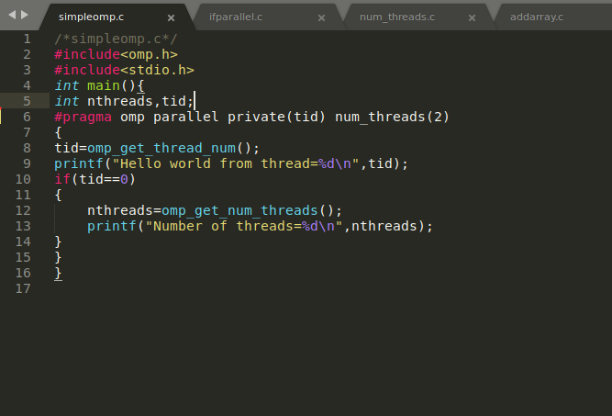

**Output:**

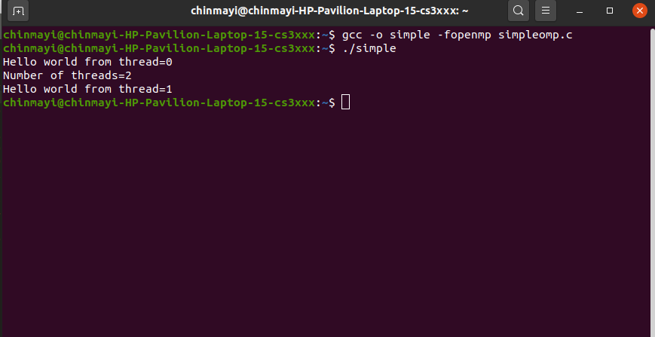

1. **Using omp_set_num_threads() Method:**

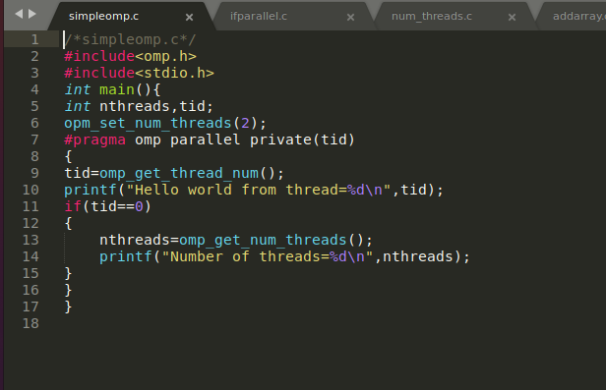

**Output:**



**2. ifparallel.c**

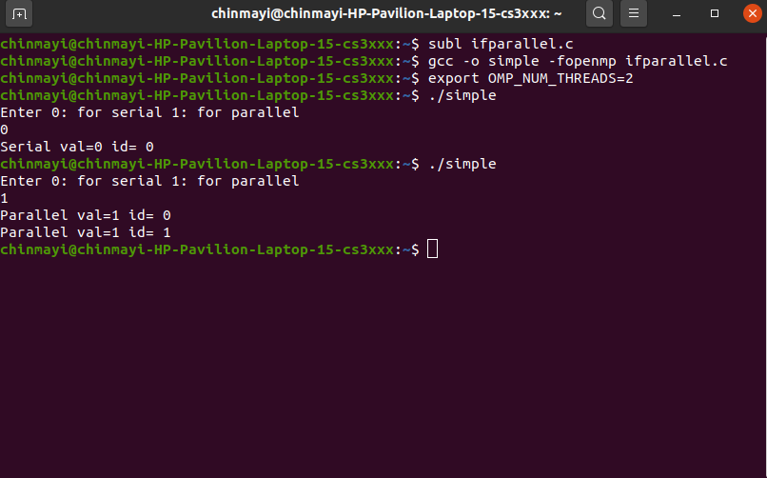

**3. num_threads.c**

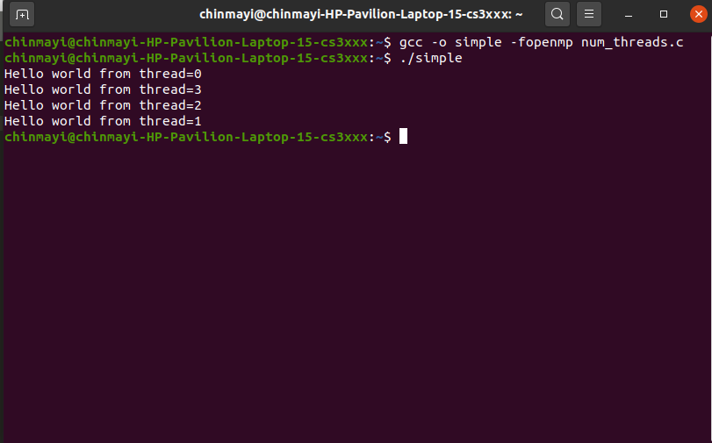

**4.Write a C/C++ parallel program for adding corresponding elements of two arrays.**

**a. Chunk=2 n=20**

**Each thread id has 10 i values.**

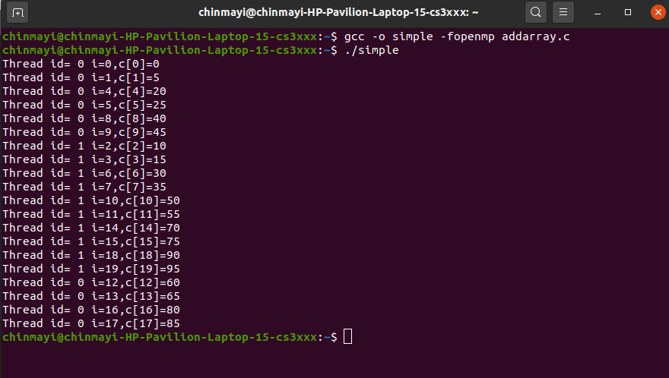

**b. Chunk= 4 n=16**

**Each thread id has 4 i values.**

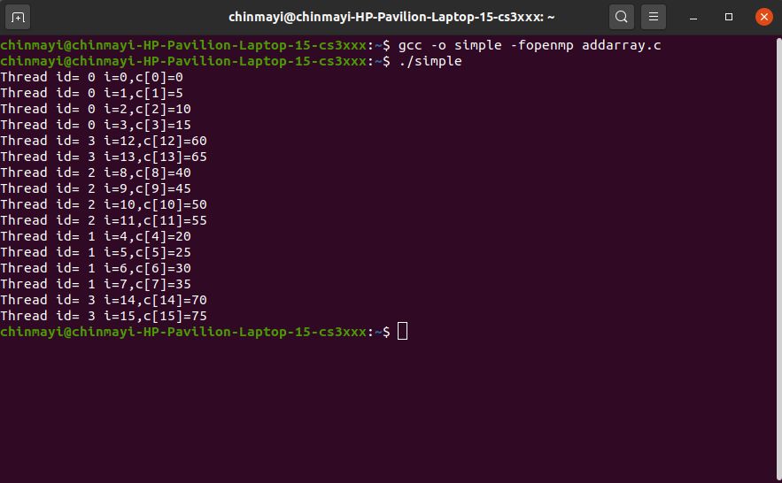

**c. Chunk = 5 n= 15**

**Each thread id has 5 i values.**

